INVOKING EXTRANAL URL INTO STUDIO

EG: we taken extral URL from GOREST.CO.IN site

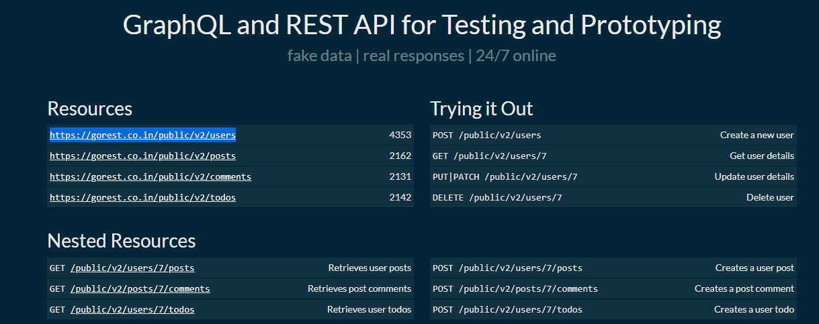

Then the URL Will be HTTP**[://gorest.co.in/public/v2/users](https://gorest.co.in/public/v2/users)**

Then **Host = gorest.co.in**

**Port= 443(**Because of External URL always 44

Resource Path= /public/v2/users

We can invoke URL in two ways:

1. InvokeRestAPI
2. Http send Request

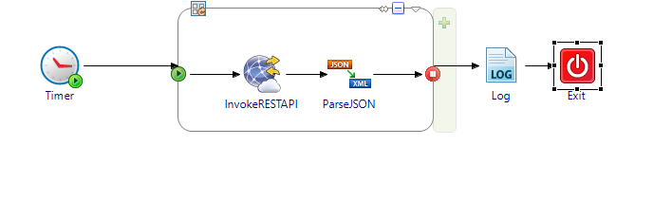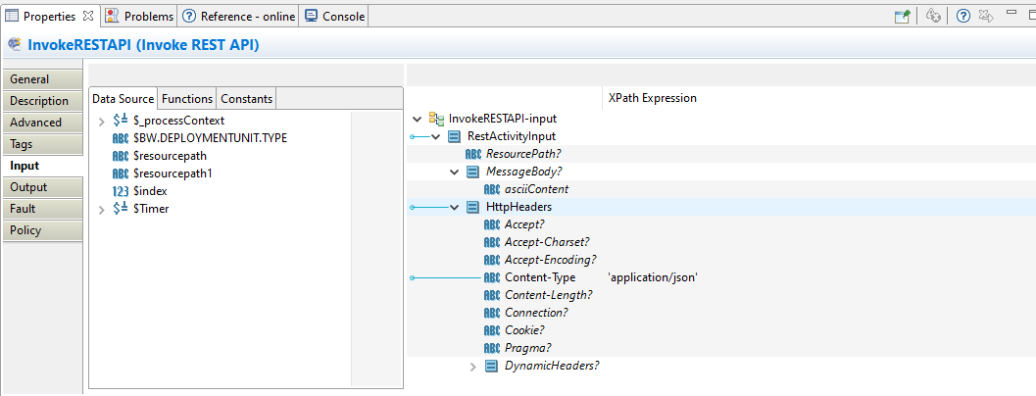

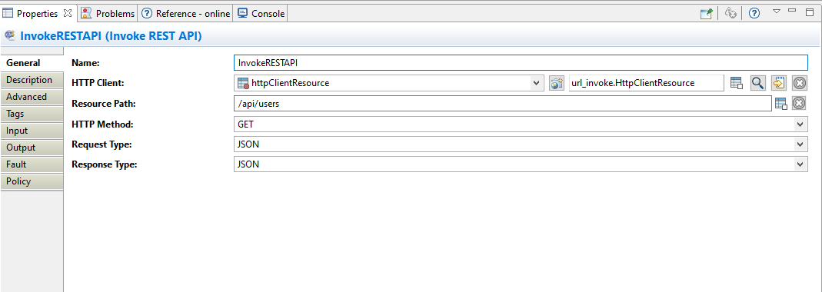

IN HTTP Resource connection

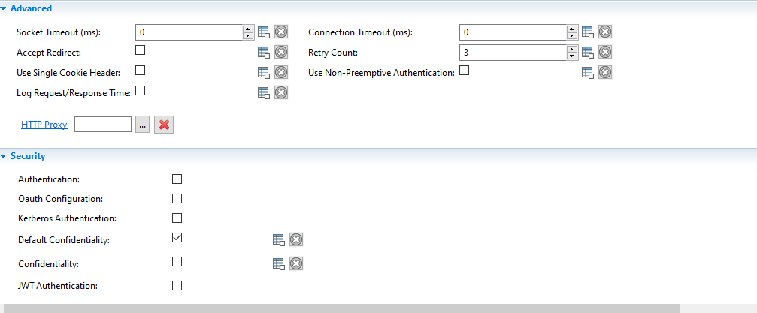

Host and port as below

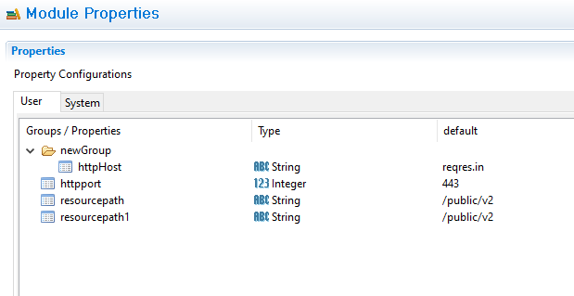

If there is any need to invoke total pages of data we need to parse the data with schema and write condition on loop for get all records